Natallia Isayenka

SI 100744884

Assignment5

1.Snapshot of grid view of Assault table

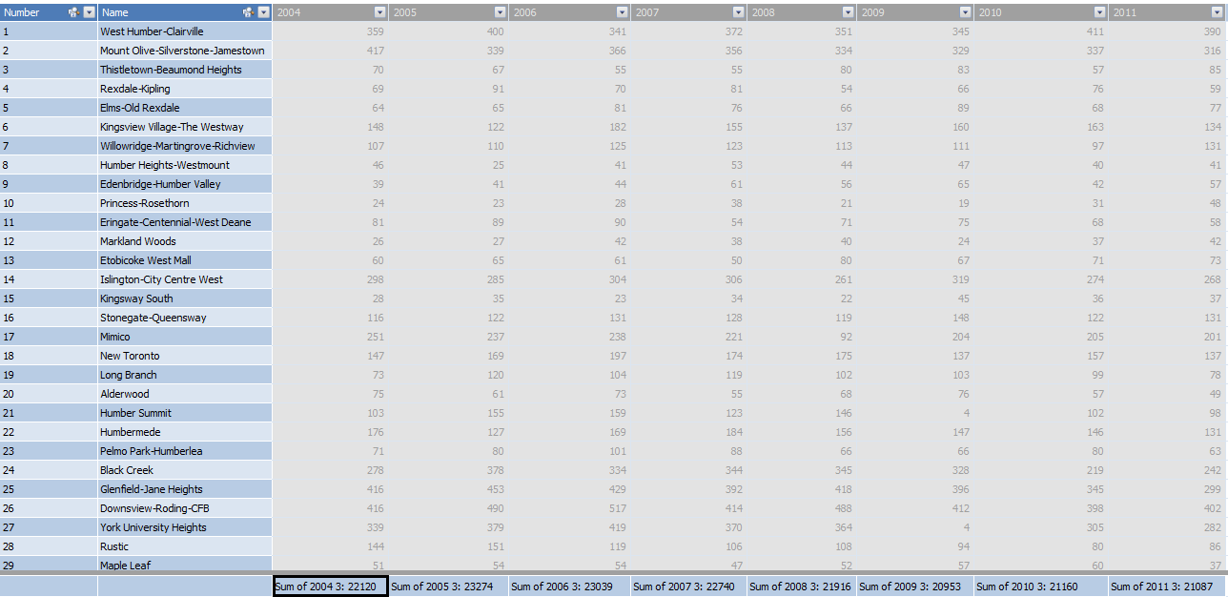

 2.Snapshot grid view of BreakAndEnter table

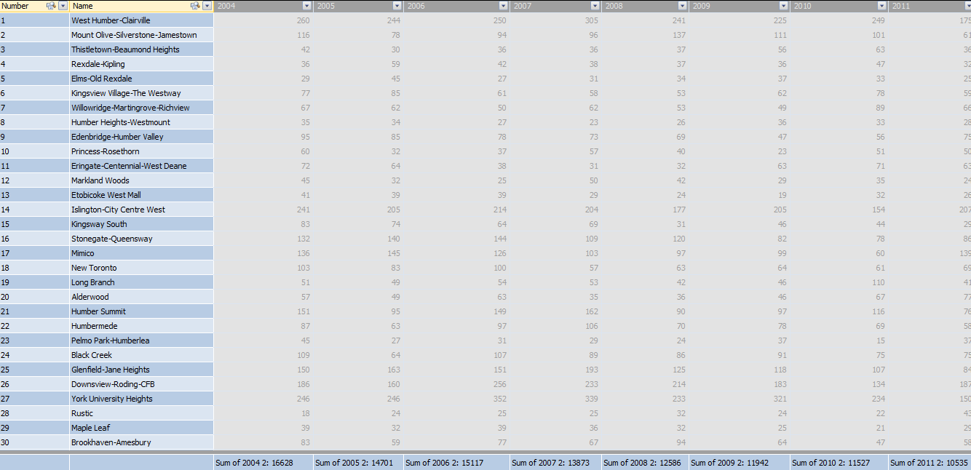

 3.Snapshot grid view of Theft table

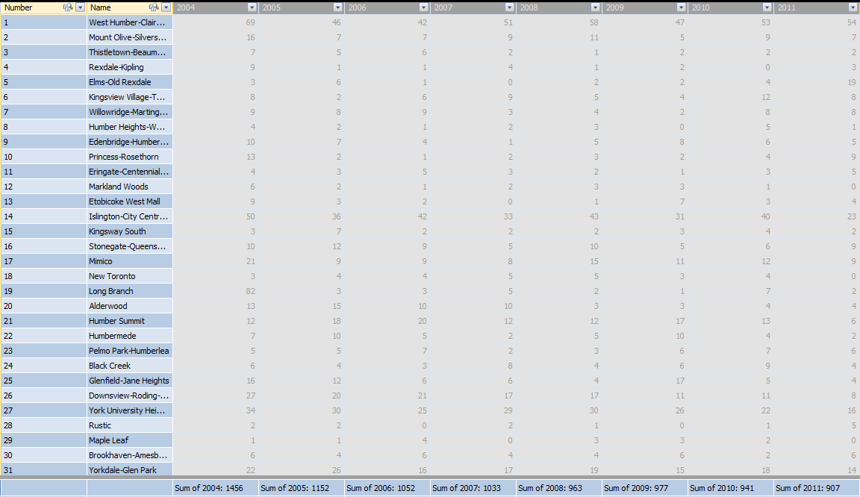

Snaphsot of diagram view

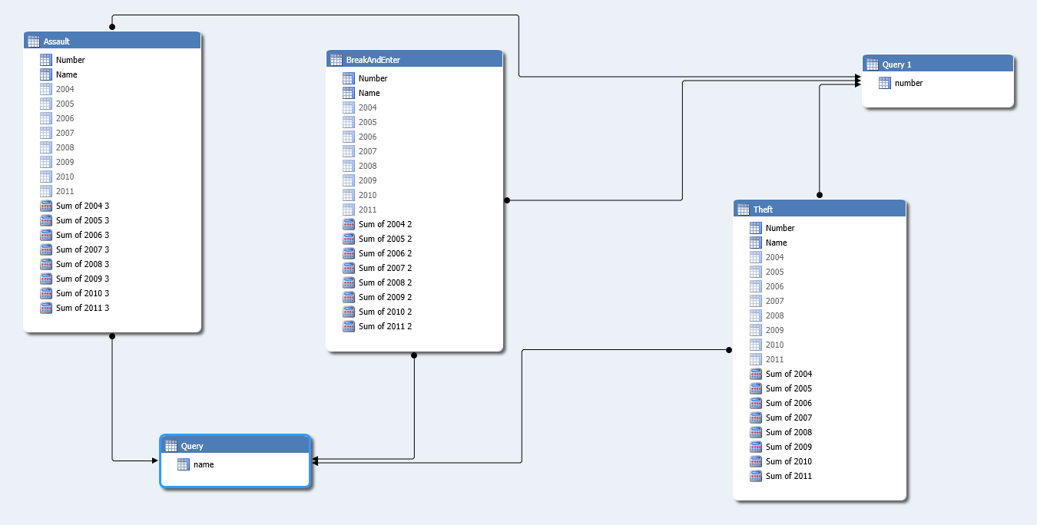

Query

select distinct name from [dbo].[Assault]

Query1

select distinct number from [dbo].[Assault]